“FLOOD GUARD”

Communication platform designed to enhance flood disaster management

Submitted in partial fulfillment of the requirements of the degree of
Bachelor of Computer Engineering

by Akanksha Jagtap Ishika Jain Sakshi Kakad Arati Kokitkar

Under Guidance of

Dr. J. R. NANDWALKAR



University of Mumbai Department of Computer Engineering Datta Meghe College of Engineering plot no.98 sector-3, Airoli, Navi Mumbai

Academic Year 2024-25


Datta Meghe College of Engineering
Airoli, Navi Mumbai

CERTIFICATE

This is to certify that the project entitled “FLOOD GUARD” is bona fide work of “Akanksha Jagtap, Ishika Jain, Sakshi kakad, Arati Kokitkar” submitted to the university of Mumbai in partial fulfillment of the requirement for the award of the degree of “undergraduate” in “computer engineering”.

Dr. J.R.Nandwalkar Dr. A. P. Pande Dr. P.A Dode Project Guide Head of the Department principal


Datta Meghe College of Engineering

Airoli, Navi Mumbai

Project Approval

This project report entitled “FLOOD GUARD” of the students “Akanksha Jagtap, Ishika Jain, Sakshi kakad, Arati Kokitkar” approved for the degree of computer engineering.

Internal Examiner External Examiner
Date: Date:
Place: Place:

Declaration

We declare that, this written submission represents our ideas in our own words and where others' ideas or words have been included; we have adequately cited and referenced the original sources. We also declare that, we have adhered to all principles of academic honesty and integrity and have not misrepresented or fabricated or falsified any idea/data/fact/source in our submission. We understand that any violation of the above will be cause for disciplinary action by the institute and can also evoke penal action from the sources which have thus not been properly cited or from whom proper permission has not been taken when needed.

Name of the Students Signature

Akanksha Jagtap -33

Sakshi Kakad - 41

Arati Kokitkar - 48

Ishika Jain - 34
Acknowledgement

Motivation and guidance are the keys towards success. I would like to extend my thanks to all the sources of motivation.

We would like to grab this opportunity to thank Dr. P. A. Dode, principal for encouragement and support he has given for our project.

We express our deep gratitude to Dr. A. P. Pande, head of the department who has been the constant driving force behind the completion of this project.

We wish to express our heartfelt appreciation and deep sense of gratitude to my project guide Dr. J.R. Nandwalkar for his encouragement, invaluable support, timely help, lucid suggestions and excellent guidance which helped us to understand and achieve the project goal. his/her concrete directions and critical views have greatly helped us in successful completion of this work.

We extend our sincere appreciation to all professors for their valuable inside and tip during the designing of the project. Their contributions have been valuable in so many ways that we find it difficult to acknowledge of them individually.
We are also thankful to all those who helped us directly or indirectly in completion of this work.

Place: Name of the Student
Date: Akanksha Jagtap -33
Sakshi Kakad-41
Arati Kokitkar-48
Ishika Jain-34

ABSTRACT

Flood Guard is a comprehensive flood monitoring and management platform designed to assist communities in disaster preparedness and response. Flooding is a destructive natural disaster that causes significant loss of life, property damage, and disruption. With climate change increasing the frequency of such events, there is a need for a proactive flood management system. Traditional warning systems relying on TV and radio lack real-time updates and personalized alerts, reducing their effectiveness. Flood Guard addresses these challenges by delivering location-specific alerts, weather updates, and warnings through multiple channels, including SMS and offline features, ensuring accessibility during power or network outages. It also empowers users to report real-time flood conditions, contributing to better forecasting and flood mapping. By integrating community input, administrative oversight, and automated alerts, Flood Guard enhances preparedness, minimizes flood impacts, and fosters resilient communities.

List of Figures

Sr. No. | Name of the Figure | Page No.
1 | System flow diagram | 24
2 | Uml Sequence diagram | 26
3 | Login with correct credentials | 48
4 | Show error message | 48
5 | Admin receives SOS with location | 49
6 | Retry message or fail | 49
7 | User receives alert instantly | 49
8 | FloodGuard Application | 60
9 | FloodGuard Dashboard | 60
10 | Flood Alerts | 60
11 | weather features | 60
12 | SOS alert | 61
13 | User want to send emergency SOS | 61
14 | User send SOS to Admin for help | 61
15 | Admin send confirmation to user | 61
16 | Admin dashboard with user login/register info | 62
17 | SOS alerts send by user to admin for help | 62
18 | SOS with live map tracking of user | 63
19 | Community Forum | 63

List of Tables

Sr. No. | Name of the Table | Page No.
1 | Forum comments Database | 38
2 | Admin Database | 39
3 | User database table | 39
4 | Alert database | 40
5 | SOS alert database | 40
6 | Types of testing | 47
7 | Test cases | 47
8 | Bug tracking and resolution | 48

 |  | INDEX
ACKNOWLEDGMENT |  |  | i
ABSTRACT |  |  | ii
LIST OF FIGURES |  |  | iii
LIST OF TABLES |  |  | iv
1 | INTRODUCTION |  | 1
 | 1.1 | INTRODUCTION | 2
 | 1.2 | MOTIVATION | 3
 | 1.3 | APPLICATION | 4
 | 1.4 | ORGANIZATION OF REPORT | 5
2 | LITERATURE SURVEY/ EXISTING SYSTEM |  | 6
 | 2.1 | LITERATURE SURVEY | 7
 | 2.2 | EXISTING SYSTEM | 10
3 | LIMITATION OF EXISTING SYSTEM OR RESEARCH GAP |  | 11
 | 3.1 | LIMITATION OF EXISTING SYSTEM | 12
 | 3.2 | RESEARCH GAP | 14
4 | PROBLEM STATEMENT AND OBJECTIVE |  | 15
 | 4.1 | PROBLEM STATEMENT | 16
 | 4.2 | OBJECTIVES | 17
5 | PROPOSED SYSTEM |  | 18
 | 5.1 | ANALYSIS/FRAMEWORK/ ALGORITHM | 19
 | 5.2 | DESIGN DETAILS | 22
 | 5.3 | METHODOLOGY PROPOSED | 28
 | 5.4 | MATHEMATICAL MODELS AND FORMULAS USED FOR MODEL  TRAINING | 31
6 | TECHNOLOGY USED |  | 33
 | 6.1 | DETAILS OF TECHNOLOGY | 34
 | 6.2 | PERFORMANCE METRICES | 41
 | 6.3 | SOFTWARE AND HARDWARE REQUIREMENT | 44

7 | TESTING |  | 46
 | 7.1 | OBJECTIVE OF TESTING | 47
 | 7.2 | TEST CASES | 47
 | 7.3 | TESTING OUTCOMES | 48
8 | RESULTS AND DISCUSSIONS |  | 50
 | 8.1 | CODING PART | 51
 | 8.2 | RESULTS | 60
9 | CONCLUSION AND FUTURE WORK |  | 64
 | 9.1 | CONCLUSION | 65
 | 7.2 | FUTURE WORK | 66
10 | REFRENCES |  | 67
 | 10.1 | REFRENCES | 68
11 | PUBLICATIONS |  | 69
 | 11.1 | PUBLICATION STATUS | 70
12 | PLAGARISM REPORT |  | 71
 | 12.1 | PLAGARISM REPORT | 72

CHAPTER 1 INTRODUCTION

INTRODUCTION

Introduction

Floods are among the most dangerous natural disasters, leading to loss of life, destruction of property, and significant disruptions in communities. With climate change resulting in more extreme weather patterns, the frequency and intensity of floods are on the rise, making it crucial for individuals and communities to be adequately prepared to respond swiftly and effectively when floods occur.

Traditional flood warning systems, such as television and radio alerts, often struggle to provide real-time information and may not reach everyone, particularly those in remote or isolated areas. Furthermore, during flooding events, power outages and communication failures can hinder the timely dissemination of vital updates.

Flood Guard is designed to address these challenges by leveraging modern technology to deliver real-time flood alerts and updates via mobile applications, email notifications, and interactive maps. The platform also enables users to report local flood conditions, enhancing the accuracy of alerts and contributing to better flood mapping in the future.

By integrating automated alerts, community input, and effective management, Flood Guard aims to enhance disaster preparedness and mitigate the impacts of flooding on affected communities.

Motivation

The motivation for the Flood Guard project comes from the growing number of floods happening around the world, which are becoming more frequent and severe due to climate change. Floods can cause significant damage to homes, businesses, and lives, especially in communities that are not well-prepared for such emergencies. The tragic effects of recent floods have shown that there is a strong need for better tools to help people manage flood risks and respond quickly when disasters strike.

Flood Guard is designed to help individuals and communities by providing important information and alerts about potential floods. Our goal is to help people prepare in advance, so they can take action before a flood occurs, rather than just reacting afterward.

We also want to encourage teamwork within communities by creating a space where volunteers can coordinate their efforts to assist those in need during floods. The app includes feature interactive maps to help families affected by floods find the support they need.

Overall, the motivation behind FloodGuard is to make communities safer and more ready to handle floods. We hope to inspire a sense of preparedness and teamwork, changing how communities respond to these natural disasters.

Application
The Flood Guard project aims to provide a comprehensive solution for flood management by utilizing modern technology and community engagement. The applications of this project include:

Flood Alerts: The application delivers immediate alerts to users based on real-time data, ensuring that individuals receive timely warnings about potential flood risks in their areas.

Community Reporting: Users can report local flood conditions, which enhances the accuracy of the information disseminated and helps authorities make informed decisions. This feature fosters community involvement and situational awareness.

Multi-Channel Communication: Flood Guard leverages various communication channels, including mobile applications, SMS notifications, and interactive maps, to reach users effectively, regardless of their access to technology or internet connectivity.

Emergency Preparedness: By providing critical information and resources, the application helps communities prepare for floods more effectively. This includes educational materials on flood safety and emergency response protocols.
Data Analysis and Mapping: The collected data can be analyzed to improve flood forecasting models and create detailed flood risk maps, aiding in long-term planning and mitigation strategies.
Disaster Management for Authorities
The admin interface of FloodGuard allows government officials, disaster response teams, and NGOs to:
- View incoming SOS requests.
- Monitor flood-prone regions in real-time.
- Broadcast location-based emergency alerts.

Organization of report
This report presents the Flood Guard Communication Platform, starting with an introduction that outlines the project's background, motivation, and practical applications. It emphasis the importance of an efficient system for flood monitoring and emergency response, detailing the benefits it offers to users and authorities through real-time alerts and assistance.
Following this, the report reviews existing flood management technologies, identifying their strengths and limitations, which sets the stage for addressing the research gap. It defines the specific problem the project tackles and presents clear objectives focused on delivering timely alerts, managing SOS request. The proposed system is described, detailing its structure, design, and methodology for processing data and facilitating communication. Additionally, it covers the technologies used, including database requirements, performance metrics, and necessary software and hardware for operation. The report concludes with references to the sources that informed the project's development.

CHAPTER 2 LITERATURE SURVEY

LITERATURE SURVEY

Literature Survey
Flood management systems play a crucial role in mitigating the devastating impacts of floods, particularly in areas prone to natural disasters. Recent advancements in technology, data-driven approaches, and community engagement strategies have significantly improved their effectiveness. Flood Early Warning Systems (FEWS) have emerged as a vital component in disaster preparedness, significantly reducing property damage and enhancing community resilience. For instance, Vassar Labs has developed the aqua FLOOD platform, which employs real-time data integration and hydrological modeling to provide precise flood forecasts. By leveraging advanced technologies, such platforms enhance public safety, minimize economic losses, and foster community participation in flood monitoring and response efforts ^{[1]}. By offering detailed forecasts, FEWS empower local authorities and residents to take necessary precautions before flooding occurs, ultimately improving disaster management strategies.
Beyond FEWS, decision-support systems (DSS) incorporating spatially distributed hydrological models have been explored for their efficacy in flood risk management and agricultural planning. The integration of the SWAT hydrological model with decision- making tools enables the analysis of land use, climate change impacts, and water resource management on flood risks. A case study in Italy demonstrated the effectiveness of DSS in providing simulations and forecasts that assist stakeholders in making informed decisions about flood mitigation and agricultural strategies ^{[2]}. Such predictive capabilities allow policymakers to anticipate future risks and implement proactive measures to protect communities and livelihoods.
The use of cloud computing and Internet-of-Things (IoT) technologies has further revolutionized flood management systems, addressing the limitations of traditional human- centric approaches. IoT-based flood monitoring systems minimize human intervention by automating flood prevention and mitigation processes. Research on the Mumbai floods of 2005 illustrates how IoT-driven systems can establish self-organizing networks capable of forecasting flood events and optimizing wastewater disposal systems ^{[3]}. By collecting real-

time data from a variety of sensors, these systems continuously monitor environmental conditions and provide timely alerts, and resource allocation during flood emergencies.
A particularly noteworthy implementation is the Flood Level Monitoring System (FLMS), specifically designed for Kurla, a suburban area in Mumbai. This system utilizes machine learning algorithms to analyze historical data on rainfall, water levels, and other relevant parameters, achieving a high degree of accuracy in flood predictions. As a web-based application, FLMS provides real-time flood alerts to users, keeping them informed and enabling them to take necessary precautions. Moreover, it facilitates communication with relevant personnel, allowing effective coordination during flood emergencies^{[4]}. By promoting awareness and preparedness, FLMS enhances overall community resilience.
Machine learning has gained significant attention in flood forecasting, with algorithms trained on historical climatic data to predict potential flood events. Various models have been successfully applied to flood forecasting, demonstrating the potential for advanced analytics to improve predictive accuracy^{[5]}. Researchers continue to explore these algorithms to provide a comprehensive understanding of their applications, enabling broader adoption in flood risk assessment projects. The increasing reliance on data-driven decision-making marks a major advancement in disaster management, allowing for more precise and timely responses to flooding events.
Additionally, an innovative IoT-based flood early warning system has been proposed, utilizing a network of sensors to collect real-time data on rainfall intensity, water levels, and weather conditions. This data is processed on a cloud platform to generate accurate flood forecasts and alerts. Compared to traditional early warning systems, the IoT-based approach offers advantages such as extensive monitoring of flood-prone regions and multi-channel alert delivery through mobile applications and notifications. By providing real-time information to communities, these systems enhance preparedness and facilitate quicker evacuations when necessary ^{[6]}.
Flood management has increasingly incorporated mobile applications to enhance disaster preparedness and response. One study introduced a mobile application specifically designed for pre- and post-flood management, providing users with real-time flood updates, emergency response guidelines, and disaster preparedness tools^{[7]}. The app also facilitates communication between local authorities and the public, ensuring that critical information

reaches affected communities promptly. By offering an interactive platform for disaster awareness and response coordination, this solution significantly strengthens flood resilience and improves overall disaster preparedness.
Another research effort explored the use of WhatsApp as a communication channel for real- time flood alerts. The system integrates hydrological sensors that monitor water levels and automatically send alerts to registered users via WhatsApp messages ^{[8]}. This approach ensures that flood warnings are delivered instantly, even to remote areas, reducing the risk of communication delays that often hinder disaster response.
In addition to mobile-based alert systems, video surveillance has been employed for real-time flood detection. An AI-driven video monitoring system has been developed to track rising water levels in flood-prone areas. This system utilizes advanced image processing and machine learning techniques to detect floods in real-time. Once a potential flood is detected, the system immediately alerts local authorities and emergency responders, enabling rapid intervention. Such automation enhances the efficiency of flood monitoring efforts, reducing human dependency while increasing accuracy in identifying critical flood conditions ^{[9]}.
Furthermore, advancements in IoT and wireless communication have led to the development of flood prediction systems using LoRaWAN technology. This system employs long-range wireless communication to collect flood-related data from remote locations and transmit it to centralized monitoring centers. The integration of IoT sensors with LoRa technology enhances data collection, enabling more accurate flood forecasting ^{[10]}. This approach is particularly beneficial for rural and underserved regions, where traditional communication networks may be unreliable. The scalability and efficiency of such systems contribute to more effective flood monitoring and early warning mechanisms.
The integration of advanced technologies in flood management systems represents a transformative shift in how communities prepare for and respond to floods. These innovations not only enhance predictive capabilities but also foster community engagement and resilience. As climate change continues to intensify the frequency and severity of flooding events worldwide, investing in such advanced systems is crucial for protecting lives, property, and livelihoods. Collaboration among researchers, policymakers, and communities will drive the development of more effective flood management strategies, ensuring sustainability and resilience in the face of increasing environmental challenges.

Existing Systems

National Flood Early Warning System (NFEWS)

The National Flood Early Warning System (NFEWS) is designed to predict and monitor floods across India by integrating hydrological models, meteorological data, and remote sensing technologies. This comprehensive system enables real-time assessment of rainfall, river conditions, and potential flood scenarios. By providing proactive alerts to stakeholders, including government agencies and local communities, NFEWS aims to enhance preparedness and minimize the impact of flooding events on lives and property.

Flood Forecasting System (FFS) in Kerala

Kerala's Flood Forecasting System (FFS) is a regional initiative focused on utilizing real- time data from hydrological sensors to issue localized flood alerts. Given state's susceptibility to heavy monsoon rains, FFS plays a crucial role in helping communities prepare effectively for potential flooding. By providing timely and specific warnings, system enhances local preparedness and response capabilities, ultimately aiming to reduce the risks associated with flood events.

Flood Inundation Mapping System (FIMS)

The Flood Inundation Mapping System (FIMS) is a vital tool for generating detailed maps that identify flood-prone areas based on hydrological data and land use patterns. This system aids in long-term urban planning and disaster management by providing essential information for policymakers and urban planners. By visualizing flood risks, FIMS supports strategic decision- making helps communities better prepare for potential flood events.

Central Water Commission (CWC) Flood Forecasting

The Central Water Commission (CWC) operates a robust flood forecasting system that monitors river basins across India. By collecting continuous data on river levels and flow rates, CWC provides timely flood forecasts to mitigate potential damage. This system plays crucial role in alerting communities and local authorities in advance, allowing for effective preparedness and response to flood situations, ultimately reducing impact .

CHAPTER 3 LIMITATIONS OF EXISTING SYSTEMS
OR RESEARCH GAP

LIMITATIONS OF EXISTING SYSTEMS OR RESEARCH GAP

Limitation Of Existing Systems

- National Flood Early Warning System (NFEWS)

- Data Integration Challenges: NFEWS relies on a wide variety of data sources (hydrological models, meteorological data, and remote sensing). Integrating these diverse datasets can be complex and may lead to inconsistencies or inaccuracies in flood predictions.
- Limited Localized Alerts: While it provides nationwide alerts, the granularity of alerts may not be sufficient for specific local areas, potentially missing critical localized flood events.

Flood Forecasting System (FFS) in Kerala

- Dependence on Sensor Infrastructure: The effectiveness of this system is heavily reliant on the presence and accuracy of hydrological sensors. Areas with inadequate sensor coverage may not receive timely alerts.
- Short Forecast Lead Time: The system may have limited lead time for warnings, making it challenging for communities to prepare adequately before a flood event occurs.

Flood Inundation Mapping System (FIMS)

- Static Mapping: FIMS relies on historical data and may not adequately account for changes in land use, climate patterns, or infrastructure developments, which can affect flood risk.
- Limited Real-Time Data Utilization: The system may not effectively integrate real- time data, potentially delaying responses to emerging flood threats.

Central Water Commission (CWC) Flood Forecasting

- Limitation: Broad Focus: While CWC monitors multiple river basins, its broad focus may overlook local nuances, leading to less effective localized flood management strategies.
- Limitation: Resource Constraints: Limited funding and resources can hinder the implementation of advanced technologies and infrastructure improvements necessary for more accurate forecasting.

RESEARCH GAP

Existing flood management systems provide crucial support during emergencies, but several limitations remain unaddressed. Below are key research gaps identified in these systems, which the Flood Guard platform aims to fill.

Fragmented Communication Channels:
Many existing platforms offer centralized alerts through government services, websites, or SMS. However, they lack two-way communication, preventing real-time interaction between users and responders. Flood Guard bridges this gap by enabling real-time SOS alerts and two- way interaction, enhancing coordination during emergencies.

Lack of Personalized and Predictive Alerts:
Most systems send generalized alerts, often without accurate, location-specific data. Additionally, they primarily rely on forecasts and river sensors, limiting predictive capabilities. Flood Guard addresses this by using machine learning models to generate hyper-local alerts based on real-time weather data and user locations.

Delayed Emergency Response and Coordination:
Current systems often rely on manual coordination, causing delays in rescue operations. Many notify emergency services only after floods occur, missing the chance for timely evacuation. Flood Guard automates SOS handling and provides live location tracking of users, ensuring quick response and better coordination with rescue teams.

Insufficient Community Engagement:
Most systems are top-down, with minimal involvement from local communities or volunteers. They do not encourage citizens to report incidents dynamically or allow volunteers to participate in rescue efforts. Flood Guard fills this gap by enabling citizen reporting and volunteer coordination to strengthen local disaster management.

Limited Integration of Data Sources:
Many platforms rely on single data sources (e.g., weather forecasts or sensor data), which limits the accuracy of their predictions. Flood Guard integrates multiple data streams— such as rainfall data, user reports, and sensor inputs—to ensure, real-time predictions.

CHAPTER 4
PROBLEM STATEMENT AND OBJECTIVE

PROBLEM STATEMENT AND OBJECTIVE

Problem Statement

Floods are among the most devastating natural disasters, posing severe risks to life, infrastructure, and livelihoods. In recent years, the frequency and intensity of flooding events have increased significantly due to rapid urbanization, climate change, and inadequate drainage systems. Despite advancements in technology, existing flood management solutions often lack real-time data integration, proactive alerting mechanisms, and effective emergency communication capabilities—especially in vulnerable or remote areas.

Most conventional flood warning systems rely on centralized monitoring by government bodies, which may suffer from delays in information dissemination and limited coverage. Additionally, during critical emergencies, individuals in affected regions often lack immediate ways to communicate their distress or request help. Systems that depend heavily on manual processes, slow response times, or limited outreach capabilities fail to adequately support communities in taking timely action during flood events.
There is a pressing need for a smart, responsive, and community-focused system that can provide accurate, real-time flood alerts, weather-based risk analysis, and rapid communication of emergency (SOS) messages using modern technologies. The solution must also be accessible, lightweight, and capable of functioning with basic mobile or web access.

The FloodGuard system aims to bridge these gaps by integrating weather data APIs, geolocation, and SOS functionality into a web-based platform that provides real-time alerts and enables users to send emergency messages (via email) with their live location. By leveraging open data, automated analysis, and user-friendly interfaces, the proposed system enhances public safety, improves situational awareness, and ensures timely communication during flood emergencies.

Objectives

Early Flood Detection and Prediction:

    - Implement advanced algorithms to analyze real-time and historical data for early detection and prediction of flood events.

Localized Alert System:

    - Develop a system that provides timely and localized alerts to users based on their geographic location, ensuring relevant and actionable information during emergencies.

User-Friendly Interface:

    - Create an intuitive and accessible mobile application that allows all community members, including vulnerable populations, to easily receive alerts and access flood- related resources.

Community Engagement and Education:

    - Enhance community awareness of flood risks and safety measures through educational programs, outreach initiatives, and in-app resources, fostering a culture of preparedness.

Efficient Resource Allocation:

    - Establish a framework for local authorities and volunteers to coordinate and allocate emergency resources effectively during flood events.

Collaboration with NGOs and Local Organizations:

    - Partner with non-governmental organizations and local groups to provide additional support and resources for communities in high-risk areas, enhancing the overall flood management approach.

CHAPTER 5 PROPOSED SYSTEM

PROPOSED SYSTEM

Analysis / Algorithm

Algorithms for Flood Guard System

Flood Detection Algorithm

Flood detection is based on monitoring environmental conditions such as rainfall, water levels, and historical data. The system uses a combination of machine learning models and statistical methods to predict potential flooding risks.

Decision Tree Algorithm


Overview: A decision tree is a flowchart-like structure where each node represents a decision or test, and each branch represents the outcome of that test. It's used for classification tasks.

Use in FloodGuard: The decision tree can be trained using historical weather data (e.g., rainfall, water levels) to predict the flood risk.

K-Nearest Neighbors (KNN)


Overview: KNN is a simple, supervised learning algorithm that classifies a new data point based on its proximity to the known data points in the feature space.

Use in FloodGuard: KNN can classify flood risk based on the geographic location of the user, historical rainfall patterns, and other weather conditions.

Naive Bayes Classification


Overview: This algorithm is based on Bayes' Theorem and assumes independence among the features. It's often used for classification tasks.

Use in FloodGuard: Naive Bayes can be used to predict the probability of flooding based on features such as temperature, rainfall, and water levels.

Alert System Algorithm

When the system detects a high flood risk, it needs to alert users in the affected area. This involves using an event-driven architecture and a priority system for sending alerts.

Priority Queue


Overview: A priority queue is a data structure that processes elements based on their priority. Elements with higher priority are processed before those with lower priority.


Use in FloodGuard: This ensures that users in the most affected areas receive alerts first, helping to mitigate the risk.

SOS Feature Algorithm

This algorithm helps users send an SOS alert when they are in a flood-prone area, requesting help via email instead of SMS.

Geofencing Algorithm


Purpose: Track user location and determine if they are in a flood-prone area.


Use: Identify users in flood-affected zones to receive SOS emails.

Email-based SOS System(SMTP)


Purpose: Send an SOS email to the admin with the user’s location in case of distress.


Use: When the user triggers an SOS request, their location and a message are sent to the admin for action.

Weather Data Analysis Algorithm

  - Support Vector Machine (SVM) Algorithm


Purpose: Classify weather data into flood-risk categories (e.g., flood-prone vs. safe zones) based on features such as rainfall intensity, temperature, and water levels.

Use: Analyze weather features (e.g., rainfall, temperature) and classify the regions based on their flood risk.

User Authentication Algorithm

  - JWT-Based User Authentication Algorithm


Purpose: To securely authenticate users and manage their sessions using JWT tokens for access control and session maintenance.

Use: User Registration & Login: Users provide their email and password. The password is securely hashed before being stored in the database. On login, the system verifies credentials and generates a JWT token for the user.
JWT Generation & Validation: After successful login, a JWT token is generated with user details and sent to the client. For every subsequent request, the token is verified for integrity to authenticate the user.
Token Expiration & Refresh: JWTs have an expiration time. When expired, users can use a refresh token to obtain a new access token to maintain their session.
Logout: On logout, the JWT is removed from the client’s local storage or cookies, terminating the session.

Design Details

System Design of the FloodGuard Smart Communication Platform
FloodGuard is a smart flood alert and emergency communication system designed to detect and respond to flood-related events in real time. The platform leverages live user location, real-time weather data, and automated communication workflows to assist in early warning and emergency reporting. It integrates front-end interfaces with back-end services, APIs, and a database to provide users and authorities with fast, location-based alerts. The design is modular, enabling focused functionality and scalability.

User Interaction & Emergency Reporting Module
The system interface is provided through a responsive web or mobile application that enables users to access live flood alerts and report emergencies via an SOS form. Users are required to enter essential details such as their name, mobile number, issue description, and live location coordinates, which are captured using the device’s built-in GPS via the browser’s Geolocation API. A dedicated SOS button is available to immediately raise an emergency signal. The app also presents weather updates and flood warnings relevant to the user's geographic region, providing critical situational awareness.

Real-Time Weather and Location Data Integration
FloodGuard continuously integrates data from external sources, specifically the OpenWeatherMap API, to fetch weather information using the user's live coordinates. Parameters such as rainfall intensity (rain.1h), humidity, wind speed, and general weather condition descriptors are analyzed. Based on predefined thresholds (e.g., rain.1h > 10mm, weather.main == “Thunderstorm”), the system determines the likelihood of flood risk. This logic-based processing allows FloodGuard to automate alerts without needing machine learning or manual input. The combination of weather API data and GPS-based location inputs ensures that alerts are geographically accurate and context-sensitive.

Backend Server, Processing, and Database Module
The backend server is responsible for handling incoming user data, processing alerts, and managing the application’s logic. When a user submits an SOS form, the server processes the data and stores the request in a MySQL database. Each entry includes user information, timestamp, and exact coordinates. In parallel, the server generates an

automated email containing the SOS details and sends it directly to the registered administrator or rescue authority’s email. This is done using an integrated SMTP email service, ensuring that critical alerts are instantly accessible to those in charge of emergency response.

The server also runs condition-checking scripts on the weather API data. If dangerous weather conditions are detected, it triggers internal flags to notify users in the affected regions via the app, displaying appropriate warning messages or banners.

Alert Generation and Notification System

FloodGuard’s alert system is fully automated and location-based. Users receive custom alerts through the application UI when they enter regions with high flood risk, based on API data analysis. These alerts inform users of potential dangers like heavy rainfall, thunderstorms, or rising water levels. For emergencies, the SOS feature ensures that once submitted, the system immediately dispatches an email notification containing full SOS details to the authority. Unlike other systems, FloodGuard does not rely on volunteer dispatch. It is strictly a communication tool, where timely and direct alerts reach the relevant authority without delay.

Post-Alert Monitoring and Feedback Logging

After an SOS request is resolved or acknowledged, the system optionally provides a feedback form allowing users to share their experience or suggestions. This feedback is stored in the database for further analysis, helping improve future versions of the platform. Though the system does not currently implement adaptive machine learning models, the architecture supports incremental feature improvements based on user interaction patterns, historical alert logs, and environmental behavior.

Additionally, the platform continues to monitor environmental data through weather APIs and location checks, maintaining preparedness for future events. The continuous cycle of monitoring, alerting, and feedback ensures that FloodGuard remains a reliable solution for early flood warnings and emergency communication.

System flow diagram
Yes
FloodGuard analyze weather data
Send alert to user
Receive SOS with live location of user
End
No
User stuck in flood?
Yes
No
Flood detected ?
Live location
Start
Weather data

Fig 1. System flow diagram

System Flow
Here is the explanation flowchart :

Start
- The system begins its operation from this point. It initiates by gathering weather- related information.

Weather data
- The system collects weather data, which could be sourced from APIs or other weather monitoring tools. This data is necessary for determining flood risks.

FloodGuard analyzes weather data
- The collected weather data is analyzed by system. The analysis likely checks factors such as rainfall intensity, water levels, or any other flood indicators.

Flood condition detected?
- The system now evaluates whether a flood condition exists based on the analyzed weather data:
  - Yes: If the conditions indicate a potential flood, the system proceeds to alert users.
  - No: If no flood risk is detected, the system concludes (leads to ix. End).

Send SMS alert to user
- If a flood condition is detected, the system sends SMS alerts to users in taffected areas to notify them of the potential danger.

User stuck in flood?
- After receiving the alert, users have the option to send an SOS if they are in trouble due to the flood. The system checks if any user is stuck:
  - Yes: If the user is stuck and sends an SOS, the system moves to the next step to manage the rescue operation.
  - No: If the user is not stuck or does not send an SOS, the system process ends

Receive SOS with live location of user
- If a user is stuck in a flood and sends an SOS, the system receives the SOS message along with the user's live location.

UML Sequence Diagram
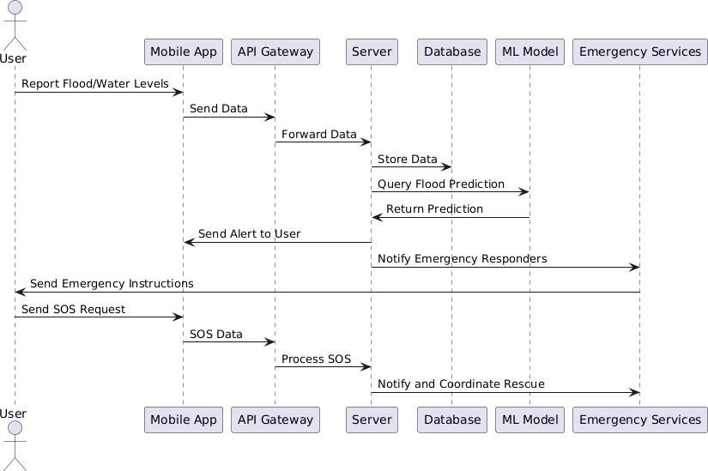

Fig 2. UML sequence diagram
This UML sequence diagram illustrates the flow of communication between different components of the Flood Guard system. It shows how users, the mobile app, API gateway, server, database, machine learning (ML) model, and emergency services interact in various scenarios like flood reporting, prediction, and SOS handling.

Actors and Components
- User
  - The end-user of the mobile application who reports flood conditions or sends an SOS.
  - Functions:
    - Reports flood levels and initiates SOS alerts if needed.
    - Receives alerts and emergency instructions.

Mobile App
  - The user interface to interact with the Flood Guard system.
  - Functions:
    - Collects user reports on flood conditions.
    - Sends SOS requests from users to the backend.
    - Receives alerts and instructions.

API Gateway
  - Acts as a middle layer to manage communication between the mobile app and backend systems.
  - Functions:
    - Forwards data from the app to the server.
    - Ensures secure communication.

Server
  - The backend logic that coordinates data processing, predictions, and alerts.
  - Functions:
    - Stores data in the database.
    - Processes SOS requests and coordinates with emergency responders.

Database
  - Stores flood-related data and SOS request logs.
  - Functions:
    - Stores user-reported data.
    - Maintains records for predictions and SOS logs.

ML Model
  - A predictive model used to analyze flood-related data.
  - Functions:
    - Processes weather and water level data.
    - Returns predictions about potential floods.

Emergency Services
  - Responders notified in the case of an SOS.
  - Functions:
    - Receive notifications about critical emergencies.

Methodology

The development and implementation of the Flood Alert and SOS Management System followed a structured methodology to ensure a systematic approach that effectively addressed the project’s goals. The methodology consisted of multiple phases: planning, design, implementation, testing, deployment, and maintenance. Each phase contributed to delivering a real-time, location-aware, and user-friendly alert system for flood-prone areas.

Planning Phase

In this initial phase, the project scope, objectives, and requirements were clearly defined. Key activities included:

  - Feasibility Study: Analyzed the technical and operational feasibility of building a system capable of real-time flood alerts, SOS messaging, and user location tracking using modern web technologies.

  - Requirement Analysis: Documented both functional requirements (e.g., user authentication, flood alert generation, SOS trigger, forum module) and non-functional requirements (e.g., responsiveness, performance, security, location accuracy). This also included identifying integration points for third-party APIs (weather, geolocation) and backend services.

Design Phase

The design phase involved planning the architecture and flow of the system, including user and admin interactions.

  - System Architecture Design: Defined the modular architecture for both frontend and backend systems. This included the integration between user interfaces (React/Next.js), real-time location services, backend APIs (Node.js/Express), and MySQL database.

  - Frontend Interface Design: Designed user-friendly and responsive interfaces using

Tailwind CSS and component-based structure in React. The UI was optimized for usability, with clear access to features like SOS, weather alerts, and forum.

  - Backend and Admin Panel Design: Created the admin dashboard layout and planned routes and controllers for managing users, alerts, and forum posts. JWT authentication and RESTful APIs were designed to secure and enable smooth communication between the systems.

  - Location & Alert Flow Design: Mapped out the process for capturing user location, fetching weather data, and displaying real-time alerts based on predefined conditions (e.g., heavy rainfall or flood forecast).

Implementation Phase
This phase involved the actual development of the system, divided into backend and frontend modules.

  - Frontend Implementation: Built with Next.js and React, featuring dynamic routing and reusable components. Axios was used for API communication, and React Hook Form and Zod for form handling and validation.

  - Backend Implementation: Developed using Node.js and Express.js. Key functionalities like user management, alert generation, SOS message logging, and admin actions were implemented. Authentication was handled using JWT.

  - Database Integration: MySQL was configured to store users, alerts, forum posts, and SOS logs. Relationships between tables were defined to support efficient data retrieval.

  - API Integration: External APIs (like weather and geolocation) were integrated to fetch location-based weather data in real time.

Testing Phase

The system underwent rigorous testing to ensure functionality and reliability.

  - Unit Testing: Conducted for individual components and backend endpoints to ensure

each part performed as expected.

  - Integration Testing: Validated the interaction between frontend and backend systems, especially in scenarios like login, SOS alert creation, and weather fetching.

  - User Acceptance Testing: Simulated user behavior to verify that the system met end- user expectations, including mobile responsiveness and real-time alert functionality.

Deployment Phase

Once testing was complete, the system was deployed for use.

  - Frontend Deployment: Hosted locally or on platforms like Vercel to ensure fast and reliable user access.

  - Backend Deployment: Hosted using Node.js-compatible platforms (e.g., Render, Heroku) with secure .env file configurations.

  - Environment Setup: All environment variables such as API keys, database credentials, and JWT secrets were managed securely.

Maintenance Phase

Post-deployment, the system is maintained for performance, security, and feature upgrades.

  - Monitoring: Error logging and performance tracking mechanisms were put in place.

  - Scalability: The architecture was designed to allow the integration of new features such as push notifications, multilingual support, and live map views.

  - Feedback Loop: User feedback was collected to guide iterative improvements to the system interface and backend performance.

Mathematical Models and Formulas Used for model training

To enhance the accuracy and reliability of flood prediction, alert generation, and rescue coordination, the FloodGuard system utilizes a combination of hydrological formulas, weather forecasting inputs, and real-time geolocation data. Below are the core models and formulas integrated into FloodGuard’s logic:

Rainfall Threshold Detection Formula
FloodGuard uses rainfall intensity thresholds to determine flood risk in a region.

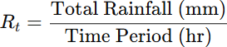

If Rt ≥ Critical Threshold, a flood alert is triggered.

Application: If rainfall exceeds 50 mm/hr, the system automatically sends alerts to users in that area.

Location-Based Risk Index (LBRI)

Combines multiple factors to assess risk for individual users.

Where ,
R_{t} = Rainfall intensity
W_{s} = Weather severity index (from API)
DL = Distance from nearest water body or flood-prone zone W1 ,W2, W3 = Weightage factors based on importance

Application: Determines whether to send just an alert or request an emergency response team

SOS Dispatch Radius Calculation

To send the nearest volunteer to a user in danger:

Where:
(x1,y1) = Coordinates of user (x2,y2) = Coordinates of volunteer D= Distance in kilometers/meters
Application: Used to identify and dispatch the closest available volunteer to an SOS sender.

Flood Alert Priority Score

FloodGuard ranks alerts using this score to prioritize areas with multiple risk factors:
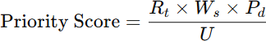

Where:
Rt = Rainfall intensity Ws = Weather severity
Pd = Population density of the area U = Number of users already alerted

Application: Helps reduce alert spam and focus on high-risk areas first.

Water Level Rise Detection (Delta Check)
Where,

Ht: Current water level
Ht-1: Water level at previous time
If ΔH ≥ Safe Limit, issue early warning.

CHAPTER 6 TECHNOLOGY USED

TECHNOLOGY USED

Details of Technology Details of Technology
The FloodGuard system utilizes a combination of frontend, backend, API, UI, and security
technologies to deliver a seamless and effective disaster management solution. Each technology plays a specific role in ensuring real-time responsiveness, location-based alerting.

Frontend Technologies (User Application)
- React 18 (with Next.js 13+)
React is a modern JavaScript library for building interactive user interfaces. Next.js enhances React with server-side rendering, routing, and API integration capabilities, making the application more efficient and scalable.

Role in Project:
  - User Interface Development: Provides the structure for creating dynamic and responsive web pages like login, dashboard, and SOS forms.
  - App Routing: Next.js handles page navigation (e.g., /dashboard/alerts, /weather, etc.) with fast loading and route-based code splitting.
  - SEO & Performance: Server-side rendering improves performance and indexing of the application in case it's hosted publicly.

TypeScript

TypeScript is a typed superset of JavaScript that enables static type checking during development, improving code quality and maintainability.

Role in Project :

  - Type Safety: Helps catch errors during development, especially while handling API data (like weather or user profile info).
  - Scalability: Makes the codebase more manageable as the project grows in complexity.
  - Code Clarity: Improves readability and self-documentation of functions and interfaces.

Tailwind CSS

Tailwind CSS is a utility-first CSS framework that allows developers to rapidly build modern and custom designs directly in the HTML/JSX.

Role in Project:

  - Responsive Design: Ensures the app is mobile-friendly and adapts to various screen sizes.
  - Rapid Styling: Eliminates the need for custom CSS files by using utility classes for spacing, colors, fonts, and layout.
  - Theme Consistency: Helps maintain a consistent dark neon theme across the entire FloodGuard interface.

Lucide React Icons

Lucide is a collection of open-source, customizable icons for React applications.

Role in Project:

  - Visual Enhancements: Adds intuitive icons to buttons, menus, weather indicators, and alert notifications.
  - UI Clarity: Improves user understanding of actions and sections using symbolic representation.

Axios
Axios is a promise-based HTTP client for making API calls from the browser to the backend server.

Role in Project:

  - API Requests: Used to connect the frontend with the backend (e.g., sending SOS alerts, fetching weather data, and submitting forum posts).
  - Error Handling: Enabled consistent handling of API responses and network failures.

Frontend Technologies (User Application)
- Node.js
Node.js is a runtime environment that allows JavaScript to be run on the server side.

Role in Project:
  - Server Logic: Powered the backend server responsible for user authentication, alert storage, forum interactions, and SOS management.
  - Event-Driven: Enabled scalable and non-blocking operations suitable for real-time user interactions.

Express.js
Express.js is a minimal and flexible Node.js web application framework.

Role in Project:
  - API Routing: Managed RESTful routes for features like login, alerts, forum posts, SOS messages, and admin functions.
  - Middleware Handling: Enabled modular use of middleware for logging, error handling, authentication, and JSON parsing.

MySQL
MySQL is an open-source relational database used for structured data storage.

Role in Project:
  - Data Management: Stores user profiles, SOS alerts, forum messages, and admin logs.
  - Relational Queries: Enables complex joins, filters, and searches for admin dashboards and reports.
  - Integration: Connected via the mysq library for seamless communication with Node.js.

JWT (JSON Web Token)
JWT is a secure method for transmitting information between parties as a JSON object, commonly used for user authentication and authorization.

Role in Project:

  - Authentication: Verifies the identity of users during login and protects private dashboard routes.
  - Session Management: Stores tokens securely in session/local storage and reuses them for authorized API access.
  - User Privacy: Prevents unauthorized access to sensitive data like SOS messages or profile info.

Nodemailer
Nodemailer is a module for Node.js applications to send emails.

Role in Project:

  - Email Alerts: Enabled the admin or system to send alert emails and notifications to users or other admins.
  - Verification (optional): Can be extended for account recovery or OTP email verification.

OpenWeatherMap API
OpenWeatherMap is a weather service API that provides real-time and forecast weather data.

Role in Project:

  - Weather Forecasting: Retrieves temperature, rainfall, and humidity data to predict flood risk.
  - Alert Triggers: The data is analyzed to raise warnings when rainfall or river levels exceed safe thresholds.
  - Live Updates: Weather is refreshed regularly to ensure timely alerts to users.

Geolocation API
The Geolocation API enables web applications to access the geographical position of a user.

Role in Project:

  - Live Location Tracking: Captures the user’s current location to provide area- specific alerts and forecast.
  - SOS Dispatch: Helps in sending the user’s live coordinates to volunteers or admins during emergencies.
  - Map Integration: Used to center maps and weather overlays based on the user’s real- time location.

React Context API
React Context API allows global state management across components without prop drilling.

Role in Project:

  - Session Handling: Maintains login state and shares token/user data across dashboard pages.
  - Alert Management: Stores alert status and shows real-time flood updates without reloading pages.
  - Data Sharing: Helps in syncing user data across components like profile, weather, and SOS.

Databases

Column Name | Data Type | Description
id | INT (Primary Key, Auto  Increment) | Unique identifier for each  SOS record.
user_id | VARCHAR(50) | Identifier of the user who sent  the SOS alert.
location | VARCHAR(100) | Description of the user's  current location.
latitude | DECIMAL(10,6) | Latitude coordinate of the  user's location.
longitude | DECIMAL(10,6) | Longitude coordinate of the  user's location.
city | VARCHAR(100) | City from where the SOS was  raised.
description | TEXT | Description or message in the  SOS alert.

Table 1. Forum comments Database

Column Name | Data Type | Description
ID | INT (Primary Key, Auto Increment) | Unique identifier for each location.
Name | VARCHAR(100) | Name of the admin user.
Email | VARCHAR(255) | Email address used for login and communication.
password | VARCHAR(255) | Encrypted password for login.
phone | VARCHAR(20) | Contact phone number of the admin.
created_at | DATETIME | Date and time the account was created
Status | VARCHAR(20) | Status of the account (e.g., active/inactive).
Updated_at | DATETIME | Date and time the account was last updated

Table 2 . Admin Database

Column Name | Data Type | Description
id | INT (Primary Key, Auto  Increment) | Unique identifier for each user.
name | VARCHAR(100) | Full name of the user.
email | VARCHAR(255) | Email address of the user.
password | VARCHAR(255) | Encrypted password for login.
phone | VARCHAR(20) | Contact number of the user.
status | VARCHAR(20) | Status of the account (e.g., active).
created_at | DATETIME | Account creation timestamp.
updated_at | DATETIME | Account last updated timestamp.
city | VARCHAR(100) | City of the user (optional).
state | VARCHAR(100) | State of the user (optional).

Table 3 . User Database

Column Name | Data Type | Description
id | INT (Primary Key, Auto  Increment) | Unique identifier for each  alert record.
title | VARCHAR(100) | Short title of the alert.
description | TEXT | Detailed description of the  alert.
severity | VARCHAR(20) | Severity level of the alert (e.g., High, Medium, Low).
location | VARCHAR(100) | Location affected by the alert.
created_at | DATE | Date the alert was created.
expires_at | DATE | Date the alert will expire.
status | VARCHAR(20) | Current status of the alert (e.g., Active, Resolved).
created_by | VARCHAR(100) | The person or authority who  created the alert.

Table 4 . Alert Database

Column Name | Data Type | Description
id | INT (Primary Key, Auto  Increment) | Unique identifier for each  SOS record.
user_id | VARCHAR(50) | Identifier of the user who sent  the SOS alert.
location | VARCHAR(100) | Description of the user's  current location.
latitude | DECIMAL(10,6) | Latitude coordinate of the  user's location.
longitude | DECIMAL(10,6) | Longitude coordinate of the  user's location.
city | VARCHAR(100) | City from where the SOS was  raised.
description | TEXT | Description or message in the  SOS alert.
status | VARCHAR(20) | Current status of the SOS  alert (e.g., pending).
created_at | DATETIME | Date and time the alert was  created.
updated_at | DATETIME | Date and time the alert was  last updated.

Table 5. SOS Alert Database

Performance metrices

To evaluate the performance and effectiveness of the FloodGuard system, several key performance metrics were considered. These metrics help in assessing the accuracy of flood predictions, efficiency of emergency response, and overall reliability of the system. Below are the detailed performance metrics used:

Accuracy
This metric measures how accurately the system predicts the occurrence or absence of a flood based on environmental data such as rainfall intensity, water level, and weather API inputs.
True Positives (TP) = 40 True Negatives (TN) = 45
False Positives (FP) = 5 False Negatives (FN) = 10

Interpretation: FloodGuard accurately detects flood and non-flood situations in 85 out of 100 cases.

Precision
Precision helps evaluate how many of the predicted floods were actually correct. This is crucial in preventing false alarms, which can cause panic among users. A high precision indicates that most alerts sent by FloodGuard are valid, making the system more trustworthy.

Interpretation: 88.89% of the flood alerts sent were correct, minimizing false alarms.

Recall (Sensitivity)
Recall is used to measure how well the system is able to detect real flood events. In disaster scenarios, missing a flood prediction (false negative) can be dangerous. A high recall ensures that most real floods are caught and alerts are sent in time.


Interpretation: The system successfully detected 80% of actual flood cases.

AUC - Area Under ROC Curve
AUC indicates how well the FloodGuard model distinguishes between flood and no-flood situations. A higher AUC means better model performance.
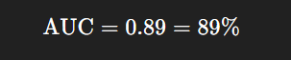
Interpretation: An AUC of 0.89 shows that the model has an excellent ability to distinguish between positive (flood) and negative (no flood) cases.

RMSE - Root Mean Squared Error
RMSE measures how much error is there between predicted flood severity and actual severity. Lower RMSE indicates better accuracy.

Event | Predicted Water Level (m) | Observed Water Level (m)
1 | 5.0 | 5.2
2 | 4.8 | 4.9
3 | 6.1 | 6.0
4 | 5.3 | 5.1
5 | 4.9 | 5.0
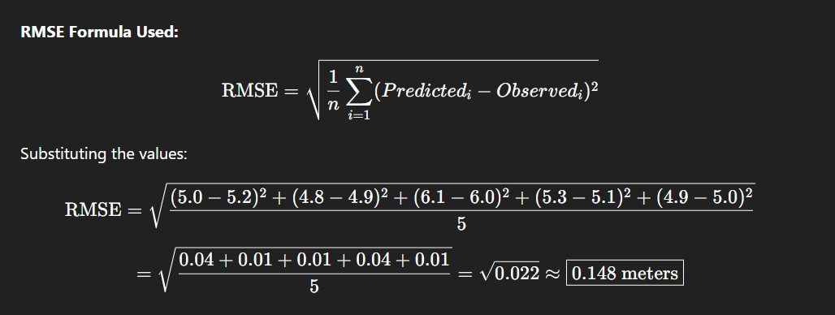

Alert Delivery Success Rate
FloodGuard sends alerts via SMS, email, and app notifications. This metric helps determine whether the communication channels are functioning properly and ensures that users are being notified on time. A high delivery rate means the system is reliable even during network congestion or outages.
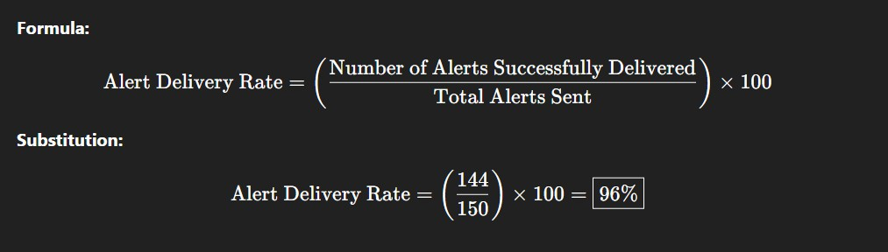
Interpretation: 96% of alerts are successfully delivered via SMS, app.

Software and Hardware Requirement

Software requirement :
The following software tools and technologies are required to develop and run project:

Operating System
Windows 10 / 11 or any Linux-based OS is suitable for development and deployment.

Backend Technologies

Node.js (version 14 or above) for running the backend server.

Express.js for creating RESTful APIs and handling routing.

Databases

MySQL for storing user credentials, weather alerts, SOS requests, and system logs.

- API & Services

OpenWeatherMap API to fetch live weather data.

Nodemailer to send emergency email notifications.

- Authentication

JWT (JSON Web Token) for secure user authentication and protected routes.

- Development Tools

Visual Studio Code for backend coding and debugging.

Android Emulator for mobile app testing.

Postman for testing backend APIs.

- Version Control

Git & GitHub for code versioning, collaboration, and backup.

- Package Management

  - npm (Node Package Manager) to manage backend libraries and dependencies.

Hardware Requirements

To develop and test the system smoothly, the following hardware specifications are recommended:

Processor
  - Intel i5 or higher / AMD Ryzen equivalent for efficient multitasking.

RAM

  - Minimum: 8 GB
  - Recommended: 16 GB (for running emulator and backend tools simultaneously)

Storage

  - At least 2 GB of free space for storing project files, databases, and dependencies.

Mobile Device

  - Android smartphone (for real-world testing of the app) or use Android Emulator.

CHAPTER 7 TESTING

TESTING

Objective
The objective of testing the FloodGuard Android application is to ensure the application performs as expected under various real-world conditions. It is essential to verify the reliability, correctness, and robustness of all core features, including user login, flood alerts, SOS messaging, live map tracking, volunteer dispatch, and weather data display.

Types of testing

Testing Type | Description
Unit Testing | Testing individual functions (login, map,  SOS)
Integration Testing | Checking modules working together (e.g.,  SOS + map + email alert)
System Testing | Full end-to-end testing of the application
User Acceptance Testing | Testing from user perspective to ensure  usability and expected behavior
Performance Testing | Tested app with slow/unstable network and  location simulation
Table 6. Types of testing

Test cases

Test  Case ID | Feature | Description | Expected Result | Actual Result | Status
TC- 01 | User Login | Login with correct  credentials | Redirect to user dashboard | Works as expected | Pass
TC - 02 | Invalid Login | Login with incorrect  credentials | Show error message | “Invalid Login” shown | Pass
TC- 03 | SOS Button | Send SOS with active internet and GPS | Admin  receives SOS with user location | Received correctly | Pass
TC- 04 | SOS Button Offline | Tap SOS with no internet | Retry message or fail | Retry message shown | Pass
TC-  05 | Admin Alert | Admin sends  flood alert | User receives  alert instantly | Alert received | Pass
Table 7. Test cases

Bug Tracking and Resolution

Bug ID | Description | Resolution
B-01 | SOS email not received on  some devices | Updated SMTP configuration  and ports
B-02 | App crashes on Android 11 during map load | Added location permission handling
B-03 | Weather API timeout on slow  internet | Implemented retry and  timeout logic
B-04 | Multiple SOS alerts sent on button press | Added debounce and confirmation popup
Table 8 . Bug Tracking and Resolution

Testing outcomes
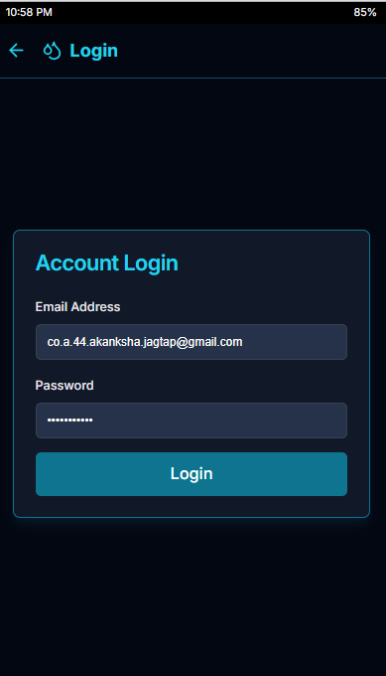
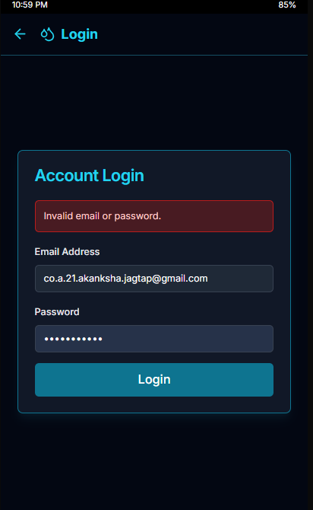
Fig -3: Login with correct credentials Fig -4: Show error message

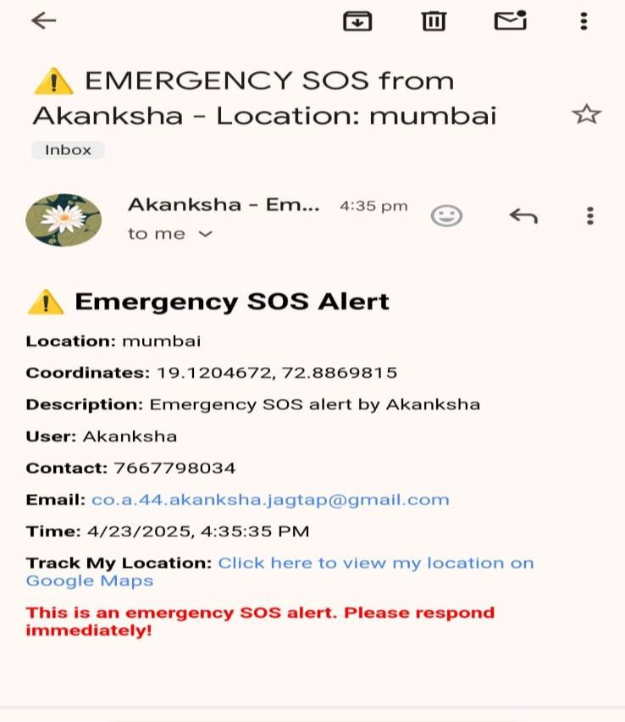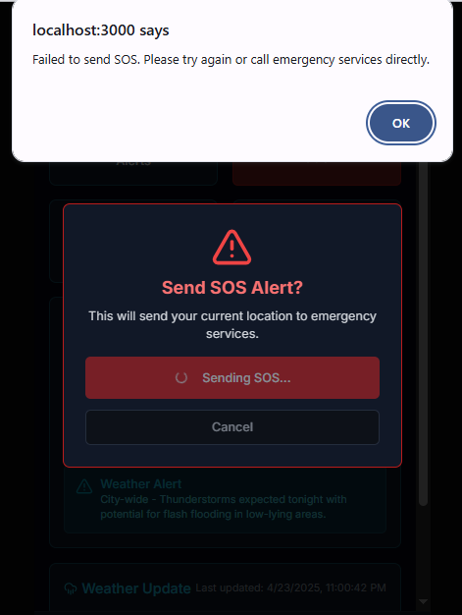

Fig -5: Admin receives SOS with location
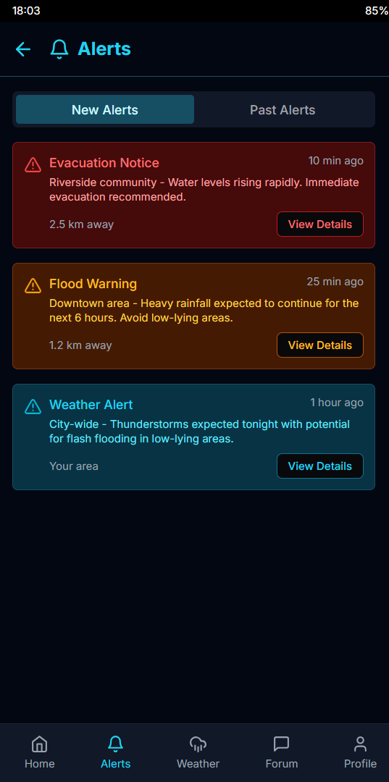
Fig -7: User receives alert instantly
Fig -6: Retry message or fail

CHAPTER – 8 RESULTS AND DICUSSIONS

RESULTS AND DISSUCUTIONS

CODING PART (code snippets) Frontend: React with Next.js and TypeScript

Weather.tsx (Fetches weather data and renders alerts based on rainfall and severity index.)
export default function WeatherPage() {
const [weather, setWeather] = useState<any>(null) const loadWeather = async () => {
const response = await fetch('http://localhost:5001/api/weather-forecast', { method: 'POST',
headers: {
'Authorization': `Bearer ${token}`, 'Content-Type': 'application/json'
},
body: JSON.stringify({ location: "mumbai" })
})
const data = await response.json()
// Process weather data setWeather({
location: data.forecast.city.name, current: {
temp: Math.round(currentWeather.temp), humidity: currentWeather.humidity,
wind: Math.round(currentWeather.wind.speed), rainfall: currentWeather.rain?.["3h"] || 0,
}
})
}}

alerts.tsx
export default function AlertPage() {
const [alerts, setAlerts] = useState([]) const fetchAlerts = async () => {

const response = await fetch('/api/alerts', { headers: { 'Authorization': `Bearer ${token}` }
})
const data = await response.json() setAlerts(data.alerts)
}
const triggerSOS = async () => { await fetch('/api/sos', {
method: 'POST',
headers: { 'Authorization': `Bearer ${token}` }
})
}
}

Login system
export default function LoginPage() { const [email, setEmail] = useState("")
const [password, setPassword] = useState("")
const handleLogin = async (e: React.FormEvent) => { e.preventDefault()
const response = await fetch('/api/login', { method: 'POST',
headers: { 'Content-Type': 'application/json' }, body: JSON.stringify({ email, password })
})
const data = await response.json() if (data.success) {
sessionStorage.setItem('token', data.token) router.push("/dashboard")
}
}

}

Sos system (Emergency SOS page where users send help requests with geolocation.)
export default function SOSPage() {
const sendEmergencyAlert = async () => { try {
const response = await fetch('/api/emergency', { method: 'POST',
headers: {
'Authorization': `Bearer ${token}`, 'Content-Type': 'application/json'
},
body: JSON.stringify({ location: currentLocation,
type: 'FLOOD_EMERGENCY',
details: emergencyDetails
})
})
// Handle emergency response
} catch (error) {
console.error('Emergency alert failed:', error)
}
}
}

Forum/Community
export default function ForumPage() { const [posts, setPosts] = useState([]) const fetchPosts = async () => {
const response = await fetch('/api/forum/posts') const data = await response.json() setPosts(data.posts)
}
const createPost = async (content: string) => {

await fetch('/api/forum/posts', { method: 'POST',
headers: {
'Authorization': `Bearer ${token}`, 'Content-Type': 'application/json'
},
body: JSON.stringify({ content })
})
}
}

Home Dashboard ( Main dashboard displays location, rainfall data, and flood alert status.)
export default function DashboardPage() {
const [waterLevels, setWaterLevels] = useState([]) const [alerts, setAlerts] = useState([])
const fetchDashboardData = async () => {
const [waterResponse, alertResponse] = await Promise.all([ fetch('/api/water-levels'),
fetch('/api/alerts')
])
const waterData = await waterResponse.json() const alertData = await alertResponse.json() setWaterLevels(waterData.levels) setAlerts(alertData.alerts)
}
}

Backend: Node.js and Express index.js (Server Configuration (index.js)) const express = require('express');
const cors = require('cors'); const app = express();

// Middleware app.use(cors()); app.use(express.json());
// Routes
app.use('/api/users', require('./routes/users')); app.use('/api/weather', require('./routes/weather')); app.use('/api/sos', require('./routes/sos')); app.use('/api/admin', require('./routes/admin')); app.use('/api/alerts', require('./routes/alerts')); app.use('/api/forum', require('./routes/forum')); const PORT = process.env.PORT || 5001; app.listen(PORT, () => {
console.log(`Server running on port ${PORT}`);
});

users.js
const express = require('express'); const router = express.Router(); const db = require('../config/db'); const bcrypt = require('bcrypt'); const jwt = require('jsonwebtoken');
const { authenticateToken } = require('../middleware/auth');
// Register User
router.post('/register', async (req, res) => { try {
const { name, email, password, phone, location } = req.body; const hashedPassword = await bcrypt.hash(password, 10); await db.execute(
'INSERT INTO users (name, email, password, phone, location) VALUES (?, ?, ?, ?, ?)', [name, email, hashedPassword, phone, location]
);
res.status(201).json({ success: true, message: 'User registered successfully' });
} catch (error) {

res.status(500).json({ error: error.message });
}
});
// Login User
router.post('/login', async (req, res) => { try {
const { email, password } = req.body;
const [users] = await db.execute('SELECT * FROM users WHERE email = ?', [email]); if (users.length === 0) {
return res.status(400).json({ message: 'User not found' });
}
const validPassword = await bcrypt.compare(password, users[0].password); if (!validPassword) {
return res.status(400).json({ message: 'Invalid password' });
}
const token = jwt.sign({ userId: users[0].id }, process.env.JWT_SECRET);
res.json({ token, user: { id: users[0].id, name: users[0].name, email: users[0].email } });
} catch (error) {
res.status(500).json({ error: error.message });
}
});
module.exports = router;

sos.js (Handles POST requests from users submitting SOS alerts.)
const express = require('express'); const router = express.Router(); const db = require('../config/db');
const { authenticateToken } = require('../middleware/auth'); const { sendAlertEmail } = require('../services/emailService');
router.post('/emergency', authenticateToken, async (req, res) => { try {
const { location, description } = req.body;
const userId = req.user.userId;

// Save SOS request
const [result] = await db.execute(
'INSERT INTO sos_requests (user_id, location, description, status) VALUES (?, ?, ?, "active")', [userId, location, description]
);
// Notify admin
await sendAlertEmail( process.env.ADMIN_EMAIL, 'SOS Emergency Alert',
`Emergency request from user ID: ${userId}\nLocation: ${location}\nDescription: ${description}`
);
res.status(201).json({ success: true, message: 'Emergency alert sent successfully' });
} catch (error) {
res.status(500).json({ error: error.message });
}
});
module.exports = router;

admin.js (Allows admins to view incoming alerts and broadcast emergency messages)
const express = require('express'); const router = express.Router(); const db = require('../config/db');
const { authenticateToken, isAdmin } = require('../middleware/auth'); router.get('/users', authenticateToken, isAdmin, async (req, res) => {
try {
const [users] = await db.execute('SELECT id, name, email, phone, location FROM users'); res.json({ users });
} catch (error) {
res.status(500).json({ error: error.message });
}
});
router.get('/alerts', authenticateToken, isAdmin, async (req, res) => { try {

const [alerts] = await db.execute('SELECT * FROM alerts ORDER BY created_at DESC'); res.json({ alerts });
} catch (error) {
res.status(500).json({ error: error.message });
}
});
router.get('/sos-requests', authenticateToken, isAdmin, async (req, res) => { try {
const [requests] = await db.execute(` SELECT s.*, u.name, u.phone FROM sos_requests s
JOIN users u ON s.user_id = u.id ORDER BY s.created_at DESC
`);
res.json({ requests });
} catch (error) {
res.status(500).json({ error: error.message });
}
});
module.exports = router;

alerts.js
const express = require('express'); const router = express.Router(); const db = require('../config/db');
const { authenticateToken } = require('../middleware/auth'); const { sendAlertEmail } = require('../services/emailService'); router.post('/create', authenticateToken, async (req, res) => {
try {
const { title, description, severity, location } = req.body;
// Save alert
const [result] = await db.execute(
'INSERT INTO alerts (title, description, severity, location) VALUES (?, ?, ?, ?)',

[title, description, severity, location]
);
// Get users in affected area
const [users] = await db.execute('SELECT email FROM users WHERE location = ?', [location]);
// Send email alerts
for (const user of users) { await sendAlertEmail(
user.email,
`Flood Alert: ${title}`,
`Severity: ${severity}\nLocation: ${location}\n\n${description}`
);
}
res.status(201).json({ success: true, message: 'Alert created and sent successfully' });
} catch (error) {
res.status(500).json({ error: error.message });
}
});
router.get('/history', authenticateToken, async (req, res) => { try {
const [alerts] = await db.execute(
'SELECT * FROM alerts WHERE location = ? ORDER BY created_at DESC', [req.user.location]
);
res.json({ alerts });
} catch (error) {
res.status(500).json({ error: error.message });
}
});
module.exports = router;

Results
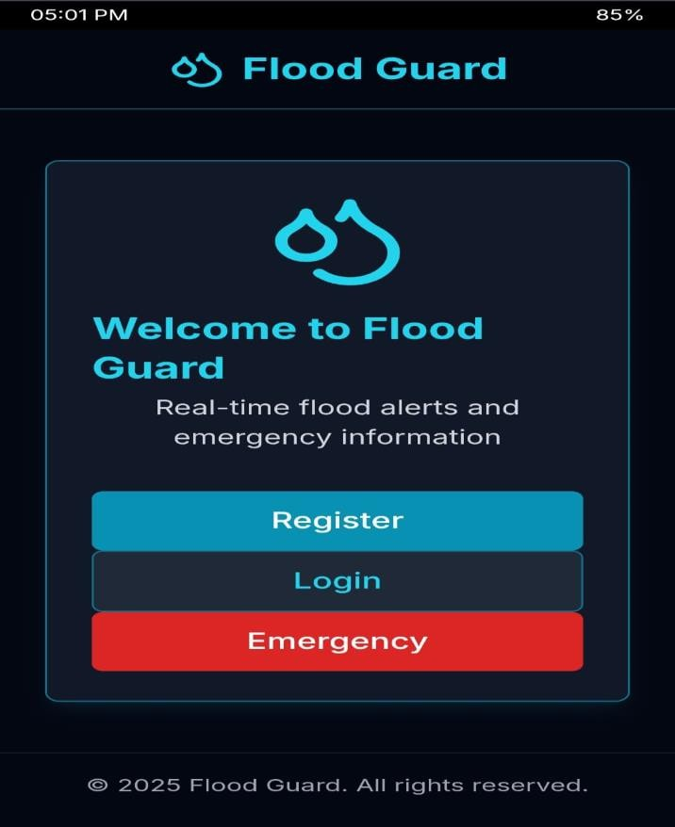
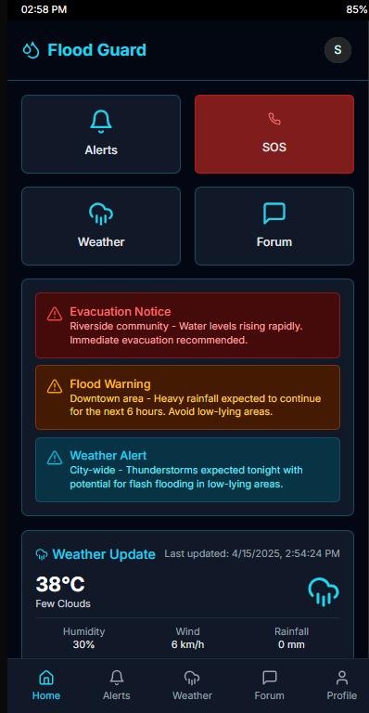

Fig -8: FloodGuard Application

Fig -10: Flood Alerts
Fig -9 : FloodGuard Dashboard
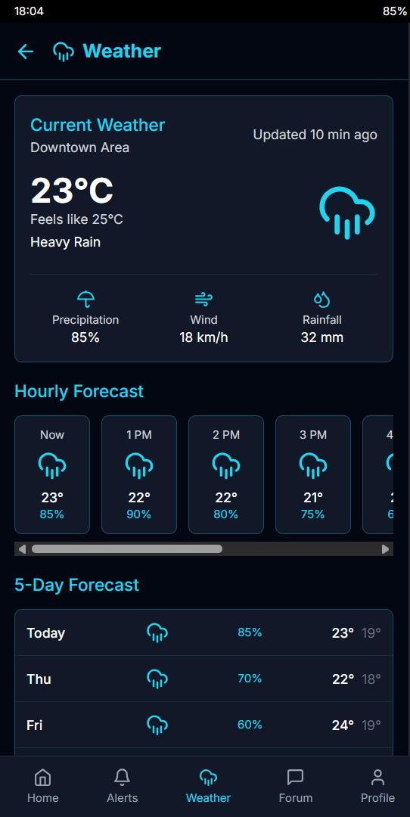

Fig -11 : weather features

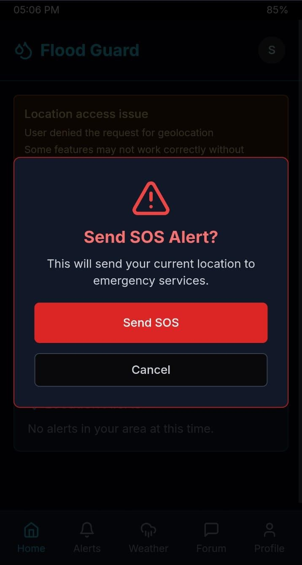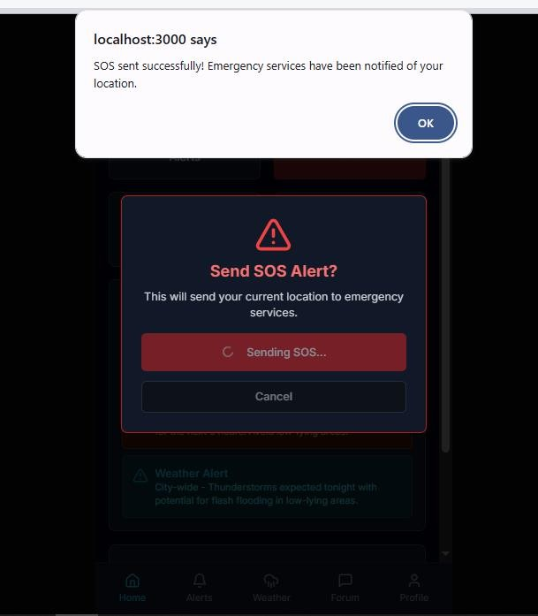

Fig -12 : SOS alert
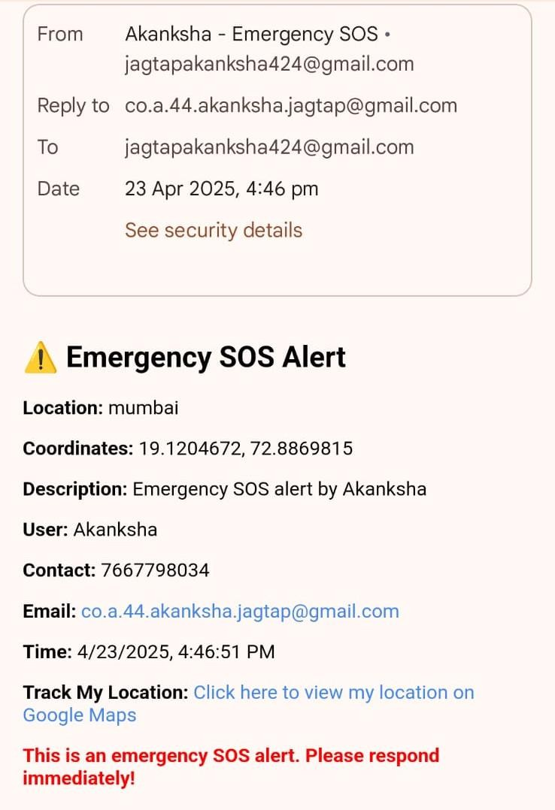

Fig -14 : User send SOS to Admin for help
Fig -13: User want to send emergency SOS
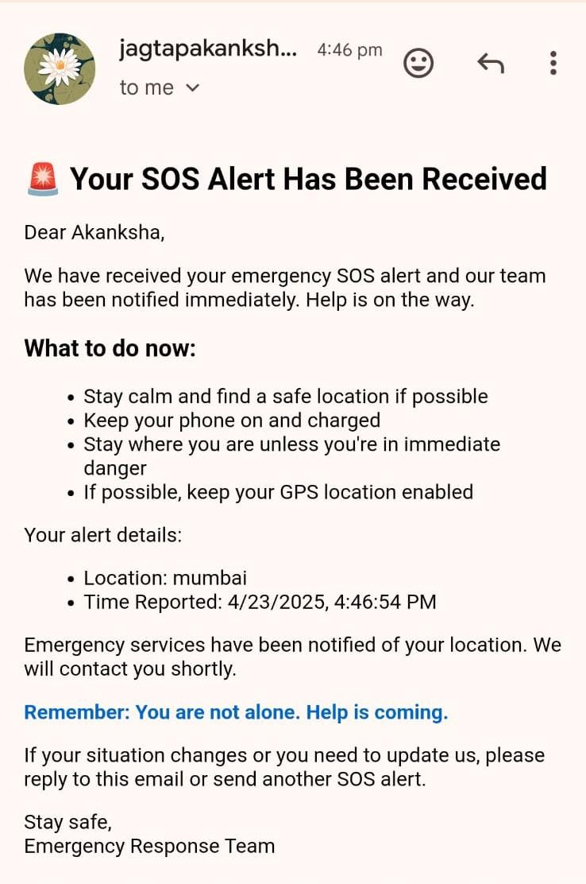
Fig -15 : Admin send confirmation to user

Admin Dashboard
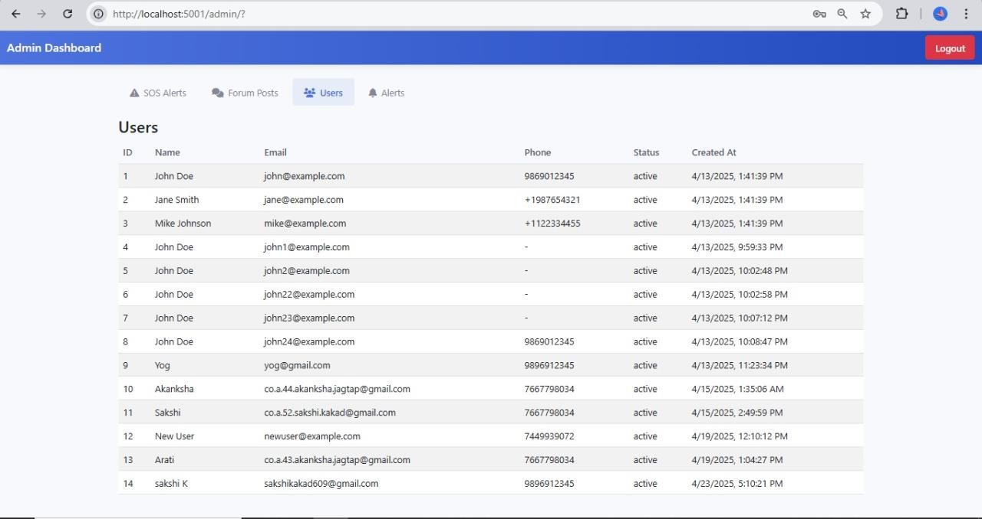

Fig -16 : Admin dashboard with user login/register info
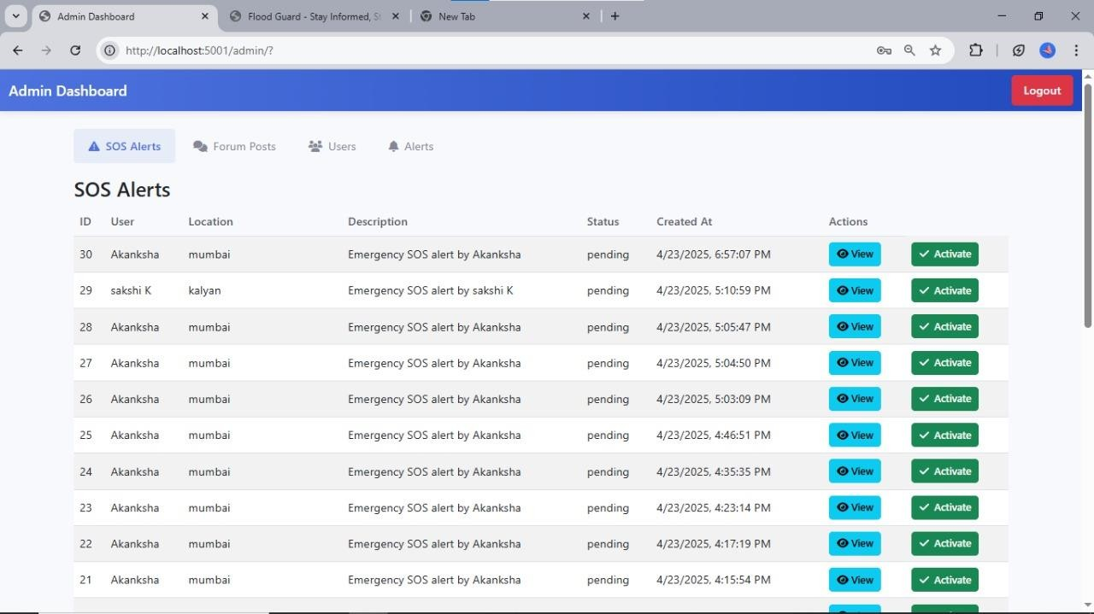

Fig -17 : SOS alerts send by user to admin for help

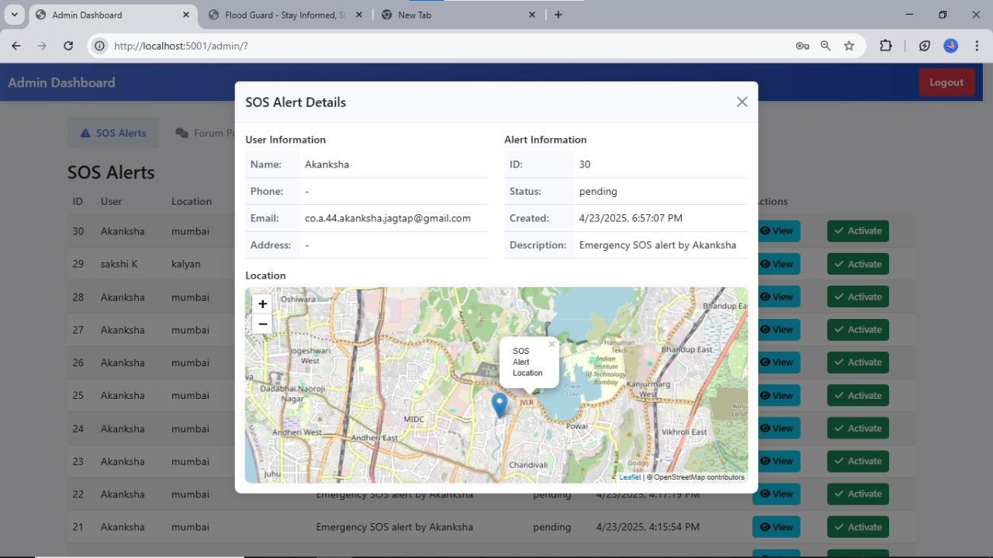
Fig -18 : SOS with live map tracking of user
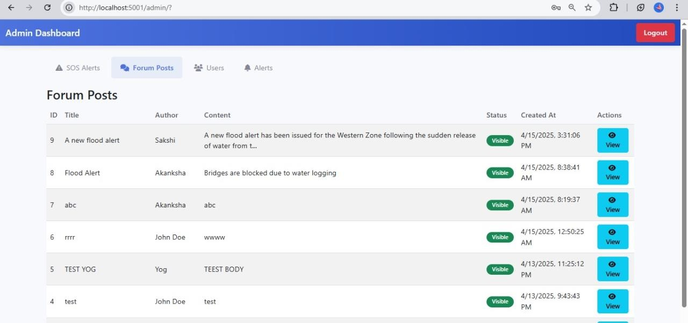
Fig -19 : Community Forum

CHAPTER – 9

CONCLUSION AND FUTURE SCOPE

CONCLUSION
The FloodGuard system is a comprehensive and user-focused solution designed to improve flood preparedness, real-time alerting, and emergency communication in flood-prone areas. By leveraging technologies such as geolocation, weather APIs, cloud-based data handling, and secure user authentication, the platform enables proactive disaster management. One of the core highlights of the system is the SOS feature, which allows users to send distress signals that include their live location, name, contact number, and issue details directly to the admin through email notifications. This ensures that emergency requests are promptly received even without mobile networks or SMS functionality, enhancing accessibility and reliability.
Additionally, the system continuously fetches real-time weather data using the OpenWeatherMap API to detect conditions like heavy rainfall or thunderstorms and trigger location-based flood alerts to users. The integration of a community forum provides a space for users to share real-time updates, report local flooding, and stay connected during disasters, promoting local awareness and peer support. All functionalities are supported by secure user authentication and streamlined backend communication with cloud-based data storage.
Overall, FloodGuard presents a scalable and responsive system that addresses the limitations of conventional flood alert mechanisms by combining automation, real-time data analysis, and community-driven communication. The platform not only enhances early warning and rescue coordination but also encourages public participation and preparedness—ultimately contributing to safer and more resilient communities during flood emergencies.

FUTURE SCOPE
The development of FloodGuard opens up several opportunities for future work to enhance its capabilities and reach. Upcoming efforts can focus on incorporating advanced flood prediction models using ML to analyze historical weather data, river flow patterns, and geographic factors for more accurate forecasting.
The system can be extended to support real-time data from IoT sensors such as water level indicators and rainfall detectors placed in flood-prone regions. Another area of future work involves improving accessibility through multi-language support, voice commands, and offline functionality, ensuring that t system is usable even in low-connectivity rural areas.
To strengthen disaster response coordination, integration with government disaster management systems and local NGOs can be implemented. Additionally, the mobile application can be enhanced with features like push notifications, user safety tutorials, and a chatbot for quick queries during emergencies.
A more dynamic and interactive admin dashboard with visual analytics, resource tracking, and live volunteer these improvements in future versions aim to create a more intelligent, inclusive, and responsive system for managing flood-related disasters.

CHAPTER – 10

REFRENCES

REFERENCES

- A. Bhattacharya, R. Sharma, and S. S. Shukla, "A comprehensive review of flood prediction models using machine learning and deep learning," IEEE Access, vol. 10, pp. 12345-12360, 2022. doi: 10.1109/ACCESS.2022.3181675.
- S. Asadi and M. K. Khosravi, "Development of an IoT-based flood monitoring and early warning system using wireless sensor networks," IEEE Sensors Journal, vol. 22, no. 1,
pp. 876-884, Jan. 2022. doi: 10.1109/JSEN.2021.3078226.
- S. Jha, D. Gupta, and M. Gupta, "Flood management system using cloud computing and Internet-of-Things," IEEE Access, vol. 10, pp. 10146661, 2021. doi: 10.1109/ACCESS.2021.10146661.
- V. Jadhav and S. Ghosh, "Flood location, management, and solution (FLMS): A flood prediction and management system for Kurla," IEEE Access, vol. 10, pp. 10392346, 2021. doi: 10.1109/ACCESS.2021.10392346.
- V. Agarwal and A. Agrawal, "Flood forecasting using machine learning: A review," IEEE Access, vol. 9, pp. 9528099, 2021. doi: 10.1109/ACCESS.2021.9528099.
- M. S. Khan, F. Jabeen, and H. A. Khattak, "IoT-based flood early warning system for effective disaster management," IEEE Access, vol. 10, pp. 10559355, 2021. doi: 10.1109/ACCESS.2021.10559355.
- K. Priyanka, S. Prasanth, K. Paveen, et al., "Pre and Post Flood Management using Mobile Application," Proceedings of International Conference on Intelligent Control Systems and Applications, 2022. Available: https://ieeexplore.ieee.org/abstract/document/10047320
- P. Author, "The Development of Early Flood Monitoring and a WhatsApp-Based Alert System for Timely Disaster Preparedness and Response in Vulnerable Communities," MDPI Proceedings, vol. 62, no. 1, pp. 18, 2022. Available: https://www.mdpi.com/2673- 4591/62/1/18.
- P. Author, "Video surveillance system for real-time flood detection and mobile app for flood alert," IEEE Xplore, 2018. Available: https://ieeexplore.ieee.org/abstract/document/8282518.
- P. Author, "Flood Prediction System using IoT and LoRa Technologies," IEEE Xplore, 2021. Available: https://ieeexplore.ieee.org/abstract/document/9673453.

CHAPTER - 11 PUBLICATIONS

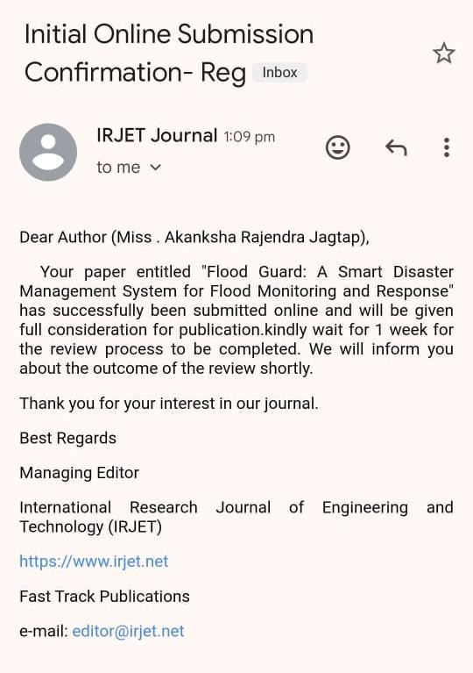

CHAPTER 12 PLAGARISM REPORT


Page 1 of 68 - Cover Page Submission ID trn:oid:::26066:413348341

Sakshi Kakad

RE-2022-544933
Batch 2
Batch 2
Universidad del Valle

Document Details

Submission ID trn:oid:::26066:413348341

68 Pages

9,282 Words

73,386 Characters

Submission Date
Apr 18, 2025, 11:54 AM GMT+5:30

Download Date
Apr 18, 2025, 11:57 AM GMT+5:30

File Name
RE-2022-544933.docx

File Size
2.0 MB

 Page 2 of 68 - Integrity Overview Submission ID trn:oid:::26066:413348341

4% Overall Similarity
The combined total of all matches, including overlapping sources, for each database.

Filtered from the Report
Bibliography Quoted Text

Match Groups

7 Not Cited or Quoted 3%
Matches with neither in-text citation nor quotation marks

1 Missing Quotations 1%
Matches that are still very similar to source material

0 Missing Citation 0%
Matches that have quotation marks, but no in-text citation

0 Cited and Quoted 0%
Matches with in-text citation present, but no quotation marks
Top Sources

0% | Internet sources
1% | Publications
3% | Submitted works (Student Papers)

Integrity Flags
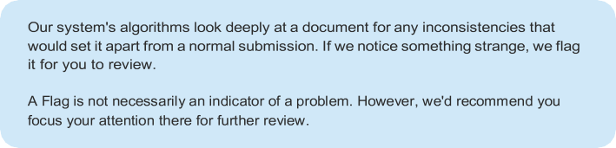
0 Integrity Flags for Review
No suspicious text manipulations found.


Page 3 of 68 - Integrity Overview Submission ID trn:oid:::26066:413348341

Match Groups

7 Not Cited or Quoted 3%
Matches with neither in-text citation nor quotation marks

1 Missing Quotations 1%
Matches that are still very similar to source material

0 Missing Citation 0%
Matches that have quotation marks, but no in-text citation

0 Cited and Quoted 0%
Matches with in-text citation present, but no quotation marks
Top Sources

0% | Internet sources
1% | Publications
3% | Submitted works (Student Papers)

Top Sources
The sources with the highest number of matches within the submission. Overlapping sources will not be displayed.

1
works

Stanford University: Machine Learning for Real-Time Flood Prediction on 2023-09-08
works
University of Cambridge: Urban Flood Risk Modelling Using Remote Sensing and IoT
works
University of oxford: Disaster Resilience and Community-Based Flood Response ....
works
of Colombo, Sri Lanka: Flood Prediction Using IoT and AI on 2023-06-05
works
Eastern University on 2024-06-28
Publication
Nature Climate Change: Flood Risk in the Age of Climate Crisis
Internet
www.floodlist.com
works
Coventry University: Integrated Flood Risk Management Framework for South Asia
<1%

<1%

<1%

<1%

<1%

<1%

<1%

